Major Insect Pests of Rice

1.Rice whorl maggot - *Hydrellia philippina* Ferino

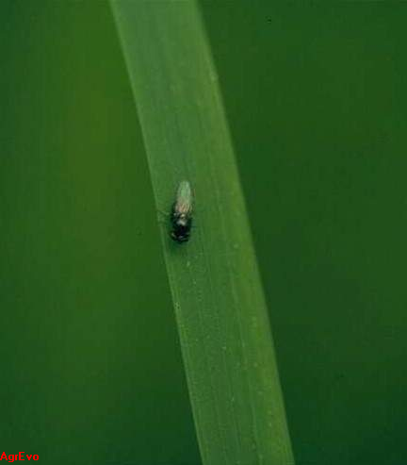

2.Rice caseworm - *Nymphula depunctalis* (Guenee)

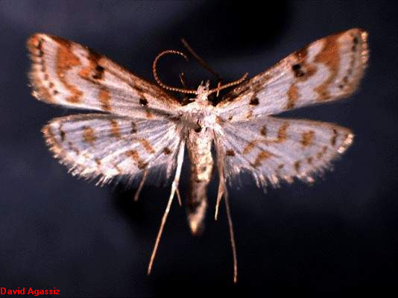

3.True armyworm - *Mythimna separata* (Walker)

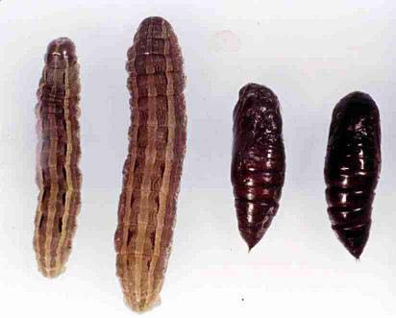

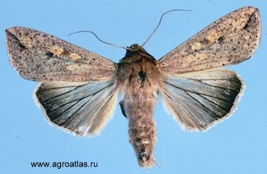

4.Rice leaf folder - *Cnaphalocrosis medinalis* (Guenee)

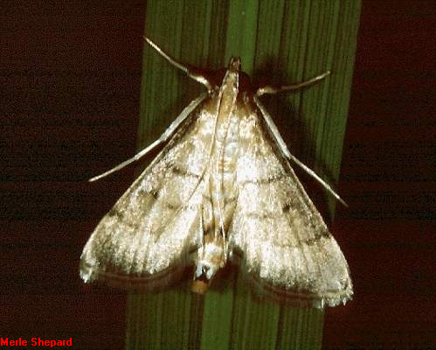

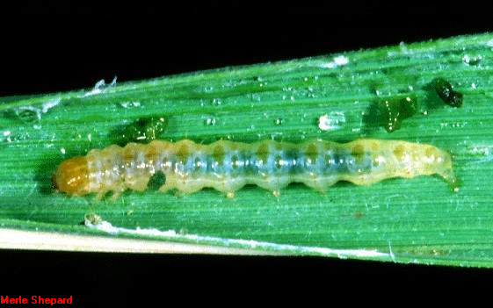

5. Striped stem borer - *Chilo suppressalis* (Walker)

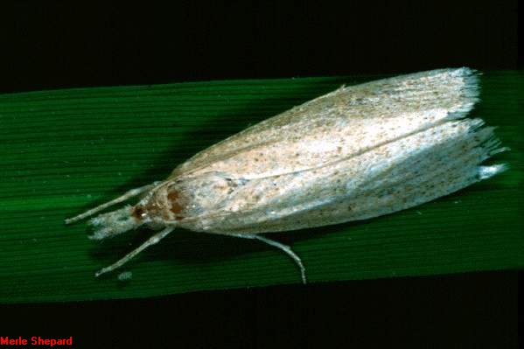

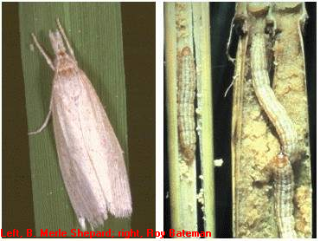

6. Yellow stem borer - *Scirpophaga incertulas* (Walker)

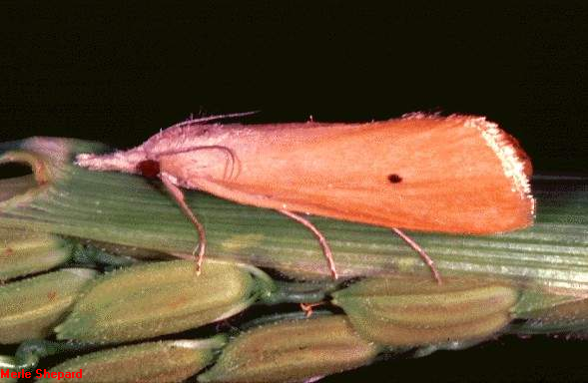

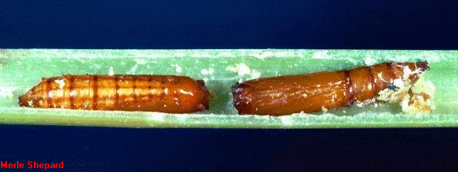

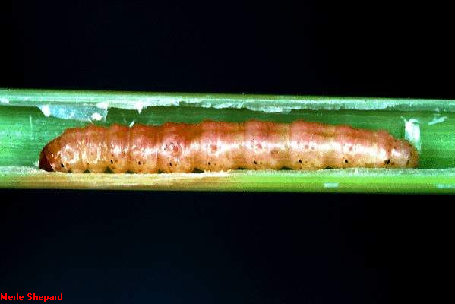

7. Pink stem borer - *Sesamia inferens* (Walker)

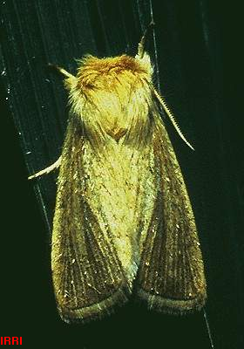

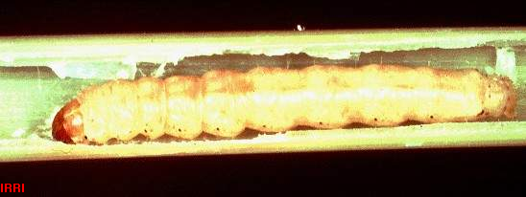

8. White stem borer - *Scirpophaga innotata* (Walker)

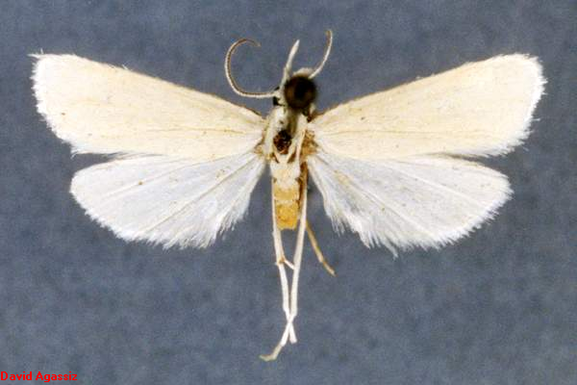

9. Green leafhopper - *Nephotettix virescens*

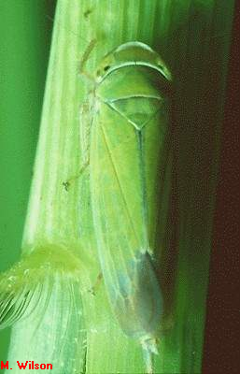

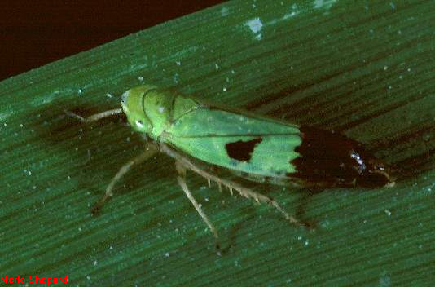

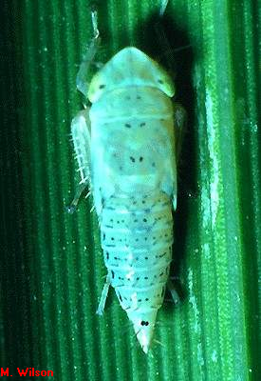

10. Brown planthopper - *Nilaparvata lugens* (Stal)

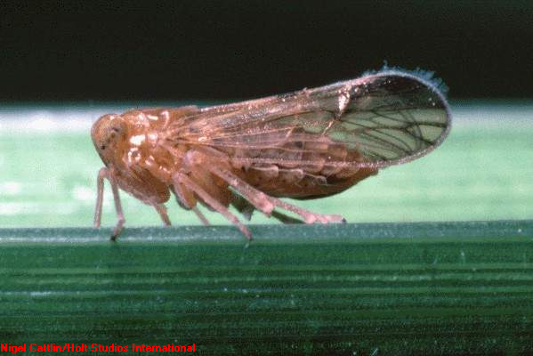

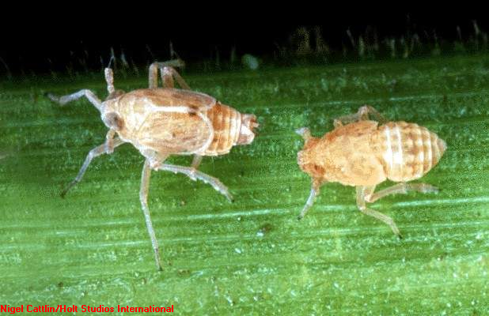

11. Whitebacked planthopper - *Sogatella furcifera* (Horvath)

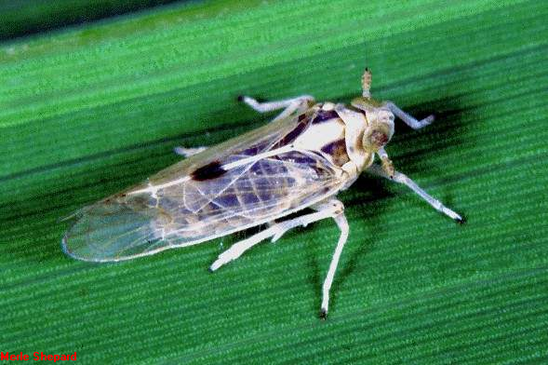

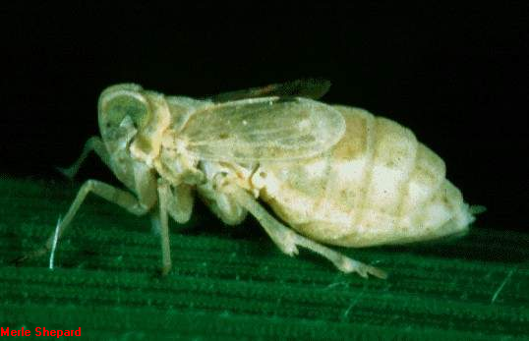

12. Rice bug *- Leptocorysa oratorius* (Fab.)

13*.* Black bug - *Scotinophara coarctata* (Fab.)

